Doing electrical work, but you just aren’t quite sure of yourself? Pick up a copy of our Basic Automotive Electricity Book. This fact filled book walks you through electricity from the basics to a complete automotive circuit diagram. And at just $7.95 it’s better than aspirin at solving electrical headaches!
Billet Electric Firewall Plug #B24D 8-circuit, $25.00

An attractive and convenient alternative to firewall ports, this Electric Plug allows you to connect/disconnect your front end wiring. Electrical work is easier during construction, modification or trouble shooting/repair. Once installed, the plug screws together for a secure connection. 2” tall x 1-1/2” wide x 7/8” deep. Clean wire exit flush to the surface. 15amp rating per circuit. 3/16” maximum wall thickness. Gasket included.
Manufactured by Watson’s StreetWorks Rod & Custom Products

Thank you for buying a StreetWorks product. Be confident that it will provide the quality and performance that you demand for your car. Please read and understand all installation instructions before beginning. Planning and preparation will make the entire process easy and quick.

1. Determine the location for you Billet Electric Firewall Plug. See the diagrams for installation, hole sizes, etc. We recommend prefitting all pieces to see how they go together.
2. Wire using the connections provided. We have shown the typical wire color coding but you may vary from this standard as you want.
3. During construction/wiring you can leave out the (4) longer cover screws. Once completed, be sure to install them for a secure connection
Typical GM Front End Wire Color Coding
Dark Blue = Right Turn Signal
Light Blue = Left Turn Signal
Brown = Park lights
Tan = Headlights Low Beams
Light Green = Headlights High Beams
Dark Green = Horn
White = Brake Switch (or optional circuit)
Orange = Electric Fan (or optional circuit)
Watson’s StreetWorks has an extensive line of street rod and custom car and truck parts with one of the largest selections of billet interior trim and electrical accessories.
Check us out online at www.watsons-streetworks.com
Thank you for buying our products!

B24D Billet Electric Firewall Plug Kit Instruction – Page 2
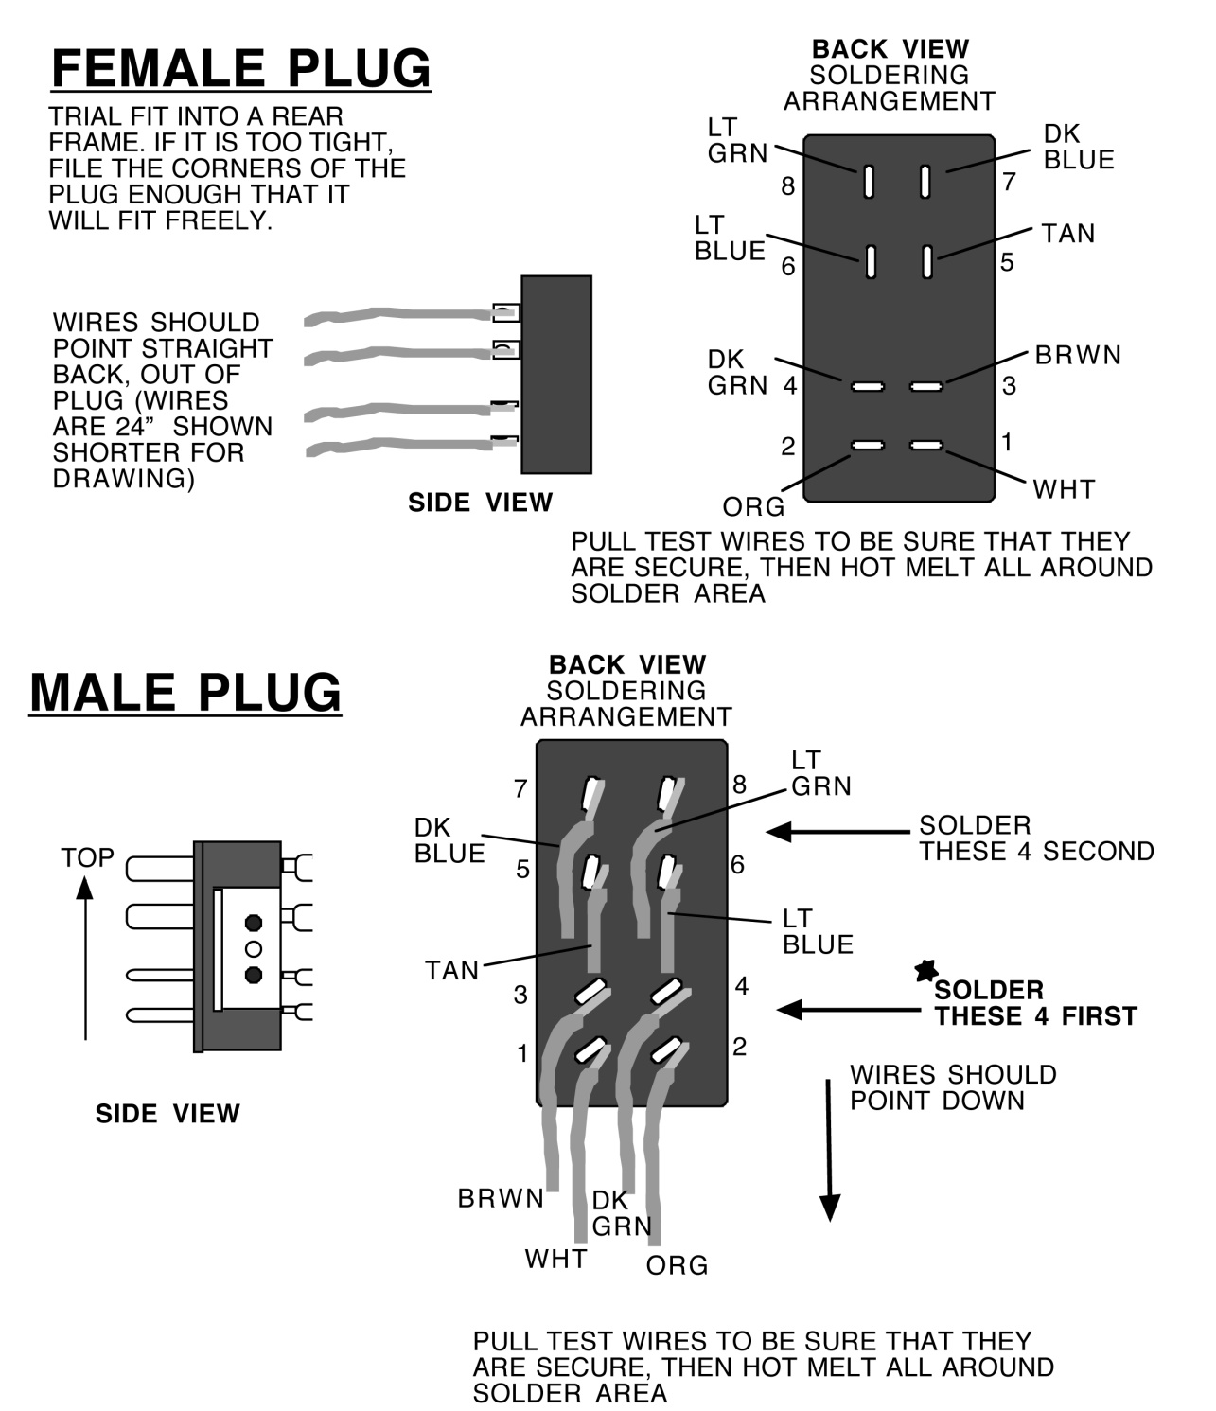

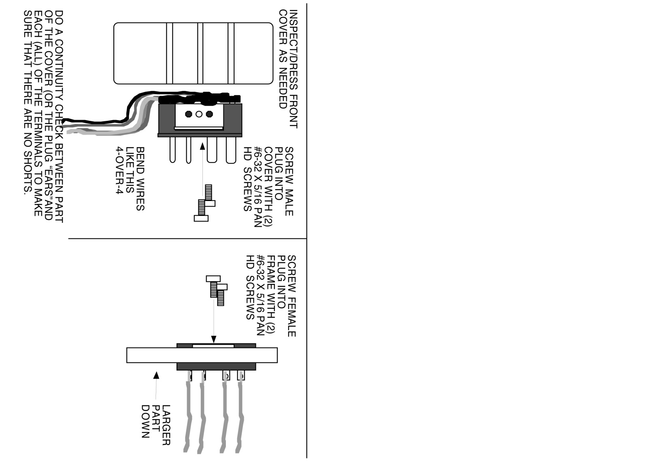
THIS WIRING DIAGRAM IS BASED ON GM WIRE COLORS USING 16 GA. WIRES.
YOU MAY USE DIFFERENT WIRE COLORS
PLEASE FOLLOW SOLDER INSTRUCTIONS AND WIRE ROUTING
WE RECOMMEND USING HOT MELT OR SILICONE TO HELP ISOLATE THE WIRES BETWEEN THE MALE PLUG AND THE FRONT COVER

11/16”
(6) HOLES, 3/16” DIA
13/16”
5/8”
5/8”
5/8”
Female Plug Firewall Hole Template
B24D Billet Electric Firewall Plug Kit Instruction – Page 3
The male plug and cover are already assembled – DO NOT DISASSEMBLE. During your wiring, it may be plugged in and unplugged as needed. once you are finished with your wiring, install the (4) long screws to secure the unit.
We have provided a gasket to seal the male plug assembly to the firewall. Trim it to fit the cover and clear the plugs
1”
Inside Cab
PLEASE NOTE: This plug has a specific orientation. The frame piece is wider in the direction that the wires will exit from the male plug and cover (down as shown). If you want the wires to exit in another direction, you must orient this female plug and frame accordingly.
The screws are provided screwed into the female plug frame. Remove and reinstall through the firewall surface to secure.
Firewall with holes
(See hole template)

