

**HOW IT WORKS**

**Accessories (On/Off),** Press & Release button.

**Start Mode,** Press and hold for 1-1/2 seconds, press and release to SHUT DOWN.

(You may also enter START MODE from ACCESSORY (On) Mode.)

You will not be able to re-start your vehicle from the “Run” position as this has been programmed out as a safety feature.

**IGNITION MODULE WIRING**

We have identified the comparable ignition switch connections (Battery, Ignition, Start and Accessory) along with our switch. When using a switch other than ours, the YELLOW wire from the module supplies +12vdc for switch illumination. The BLUE wire is the control wire for the module.

*Please see* ***NOTES*** *before wiring. Refer to your specific ignition system requirements. Please call us if you are unsure or have any questions.*

**ALWAYS Disconnect POWER at the BATTERY before doing any wiring!**

**RELATED PRODUCTS**

**#WI-RFID:** A seamless RFID security system for your Hot Dot. (Radio Frequency Identification)

**#L07-80:** 70 amp relay.

**Red Power Wire:** Included you will find an ATO/ATC fuse holder. You must put this inline on your red power wire. If you do not put this fuse inline you will void your warranty.

**Brown Wire / Acc. Feed:** This wire is good for up to 30amps. If your setup requires more than 30 amps you **MUST** run a relay of sufficient size.

This kit does ***NOT*** providethe security of a key lock ignition switch so alternate security measures are required and are the sole responsibility of the consumer. We offer a few different security options that work very well with this product.

**Accessories:** This Circuit is good for up to 30amps. If your setup requires more than 30 amps you **MUST** run a relay of sufficient size. This Mode does not power your ignition circuit.

**Ignition -** The “PINK” wire on our module is the “IGN” wire off a standard key. This circuit is rated at 30 amps. If you have an extra wire that went to the “IGN” post on your key a relay will be required to power that. (Shown Diagram on Page 3) **\*\***

The module does not have a mode for Computer Fuel Injection tuning but by disconnecting the starter wire you can get to the run position to tune. See Page 3 for diagrams.

**NOTES**

Thank you for buying a StreetWorks product. Be confident that it will provide the quality and performance that you demand for your car. ***Please read and understand all installation instructions before beginning***. Planning and preparation will make the entire process easy and quick.

**The NEW and IMPROVED Large Switch**

**Hot Dot Push Button Start**

**(Ignition / Accessory / Start / Stop Switch)**

Replace your old keyed ignition switch with our modern “Hot Dot” Push Button Starter Kit. The modern switch mounts in a 7/8” diameter hole. When activated the switch illuminates in a LED ring.

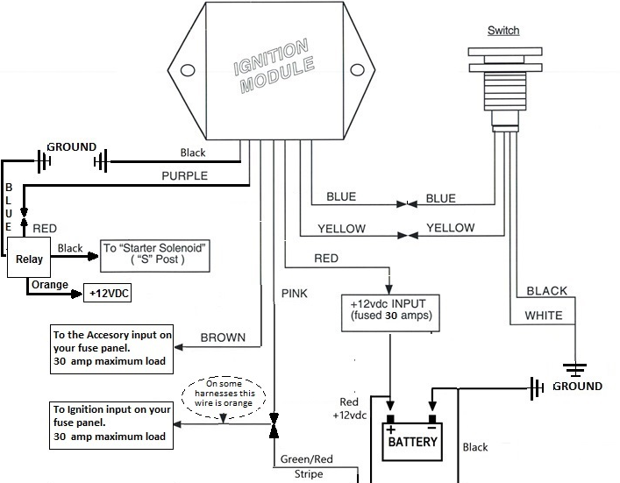

**Basic Wiring Diagram**

Pink wire to ignition input 30 amp Max load

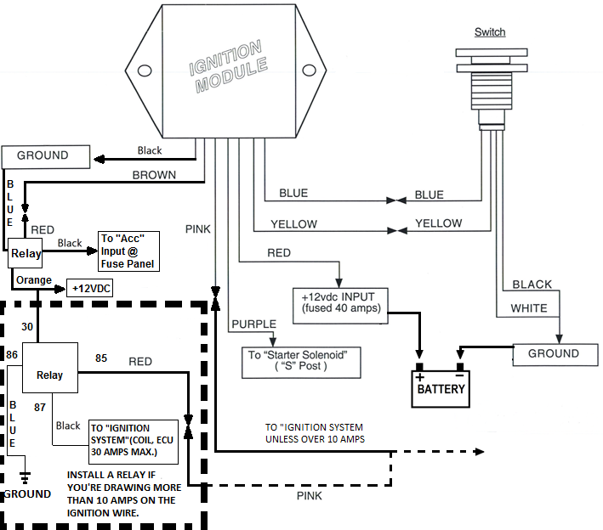

**Wiring Diagram for more IGN Powered Accessories**

**Output to IGN Powered Circuits**

**Pink wire to ignition input 30 amp Max load**

**\*\*This Relay is for additional wire on IGN Post See Page 1**

**To Ignition Module Unless over 10 Amps (Use Relay)**

**To Accessory Input on Fuse Panel 30 amp Rating**

**+12 Volt DC Input (Fused at 30 Amps)**

**To Starter Solenoid “S” Post**

**Brown**

**Purple**

**For Computer Fuel Injection Tuning**

**(Starter Bypass)**

**Option 2: (In this option you will have to have the brake or clutch on to start at all times)** This will bypass your car starting but will allow you to turn on your Ignition and Accessories when you go to start mode without your foot on the brake. Just Hold the starter button as if you were starting the vehicle.

**\*\*This option also works as a safety measure to make sure you do not start your car without your foot on the brake or clutch**

**An extra output from your Brake or Clutch switch**

Red

**To Starter Solenoid “S” Post**

Black

Orange to Battery +12v

Blue to Ground

87 post

86 post to Ground

**Starter Module**

Purple

30 post

85 post

**30/40 amp Relay**

**(Not included)**

Black

**Option 1:** This will bypass your car starting but will allow you to turn on your Ignition and Accessories. When you have the On-Off Switch Off, Just Hold the starter button as if you were starting the vehicle.

Any On-Off Switch

Blue to Ground

Orange to Battery +12v

Purple

**Starter Module**

Red

**Included Starter Relay**

**Included Starter Relay**

**To Starter Solenoid “S” Post**